The Box Model Transcript

* It can have padding, Boeder, and Margin

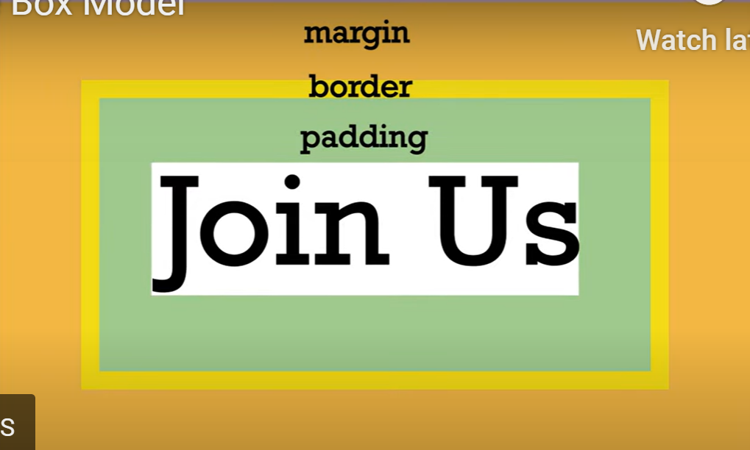



* Padding and margin are often referring to white space or space without text
* If one value is given the value apply to all 4 sides of the element
* Graphical user interface, text, application

  Description automatically generated



* If we give two values, the first value is for the top and bottom, and the second value is for the right and left.
* Text

  Description automatically generated with medium confidence



* Is you apply 4 different values, it will apply clock wise starting from top going to right, bottom and left.
* Graphical user interface, application

  Description automatically generated
* We can also apply by adding to just one side by doing like this:

* To make the image and text box the same width we can use the code below:



Browsing Developer Tools Transcript

* To inspect your code, you can click a line of code and right click and select inspect.
* On the terminal thing you can check and uncheck so see the change on your website.
* Graphical user interface, text, application

  Description automatically generated